NHS England
NHS Improvement
Job description and person specification

Position

Job title | Information Commissioning Analyst Apprentice | Directorate/ Region |  | Direct Commissioning – East of England
Pay band | AFC Band 2 | Responsible to |  | Senior Information Commissioning Analyst
Salary | £20,270 - £21,318 p.a. | Accountable to |  | Head of Acute Commissioning
Tenure | Fixed Term Contract | Responsible for |  | Responsible for day to day work assigned to Information Commissioning team
Funding Arrangements | Programme Funded | Base |  | Victoria House, Cambridge
Our Organisation |  |  | NHS England and NHS Improvement Values and Behaviours
NHS England and NHS Improvement came together on 1 April 2019 as a new single organisation. The NHS Long Term Plan focuses on delivering integrated care to patients at the local level and we can best support the NHS to deliver this as a single integrated organisation.  Our new operating model represents a strong shift to regional delivery supported by expert corporate teams. Local health systems are supported by our integrated regional teams who play a major leadership role in the geographies they manage.  We are jointly committed to creating and maintaining a fair and supportive working environment and culture, where contributions are fully recognised and valued by all and staff feel empowered to carry out their duties to the best of their abilities. As employers we are committed to promoting and protecting the physical and mental health and well-being of all our staff. This underpins our values as set out in the NHS Constitution, supports us to be an Employer of Choice and ultimately enables our employees to support the effective care of our patients.  The seven integrated regions of our joint enterprise will work with local systems to support and improve how care is provided to patients and communities. These regions will be supported by the corporate centre providing expertise and developing policy. The focus will be on guiding and managing the delivery of services through local integrated health systems, sustainability and transformation partnerships, and devolution areas. |  |  | Having listened to our staff over the last year, we aim to create a healthy and high performing organisation, underpinned by the NHS Constitution values:  - Respect and dignity.  - Commitment to the quality of care.  - Compassion.  - Improving lives.  - Working together for patients.  - Everyone counts.  Our people all have a part to play in helping to shape and develop our culture and in embedding and living these values.
Service and team |  | About the role
The East of England region is one of seven regional teams that support the commissioning of high-quality services and directly commission primary care and specialised services.  Geographically the East of England team covers an area stretching from Hertfordshire and Essex, Luton and Milton Keynes to the West and Cambridge, Norfolk and Suffolk to the East, serving a population of circa 6.4 million.  Commissioning will be central to the NHS meeting the challenges it faces today and in the future, and in ensuring that the NHS delivers the triple aim of improved population health, quality of care and cost-control. In order to deliver the triple aim, commissioning will need to continue to develop as it has since its inception.  There will be a need for commissioners to work more closely together, aligning their objectives with providers and taking a more strategic, place-based approach to commissioning. Sustainability and transformation partnerships, integrated care systems, devolution and co-commissioning will all play key roles in ensuring that the value of each pound spent in local areas is maximised. |  | As an Information Commissioning Analyst Apprentice, the post holder will work as part of a dynamic team in delivering an effective service supporting managers and staff across the Specialised Commissioning team to ensure the provision of comprehensive high quality analyst support.  To deliver an effective and competent level of clerical support and consistently deliver a “client-focused” service which promotes good customer service and effective working relationships.
Key Job specifics and responsibilities |  | Key accountabilities
Delivering High Standards  - To ensure the provision of comprehensive high quality analyst support.  Promoting equality and reducing inequalities  - To uphold organisational policies and principles on the promotion of equality.  - To create an inclusive working environment where diversity is valued, everyone can contribute, and everyday action ensure we meet our duty to uphold and promote equality.  Working with others  - To work in partnership with others and as part of cross directorate teams to deliver successful outcomes.  - To coordinate activities of other officers in the awareness of the business agenda with specific reference to communication of directorate and corporate activities.  Developing an excellent organisation  - To support the organisation’s ways of working, model its values and champion the NHS Constitution  Planning and Organising  - Carry out Information Commissioning tasks, working independently, taking guidance and advice from line manager.  - Manage own time effectively.  Service Improvement  - Input data to computerised systems.  - To assist in the maintenance and completion of accurate data returns.  - To provide support to the Specialised Commissioning team in delivering its objectives.  - Flexible approach to work in line with the needs of the business.  Analysis & Judgement  - Respond to queries from the team or external stakeholders.  - Resolve issues where possible, escalating as required.  Communication  - As a point of contact for the team managing a range of queries and issues from colleagues and a range of stakeholders.  - Explain sometimes complex processes in an easy to understand way to colleagues or external organisations.  - Promote a positive image of the service in all dealings; being professional, tactful and helpful.  Financial Management  - To support Specialised Commissioning team in monitoring contracts using relevant information.  Policy & Service Development  - Follow all relevant policies and procedures. |  | - Dealing with routine enquiries in a pleasant and helpful manner, communicating relevant information to stakeholders, referring to others as appropriate.  - Answer routine telephone calls, taking messages and passing on information accurately to the relevant departments/person.  - Ensure that general office supply levels are monitored, and stock replenished when necessary/ if applicable.  - Promote the image of the department, checking that notices and leaflets are up to date and well presented.  - Ensure that all complaints, comments and suggestions are dealt with appropriately, in accordance with policy, resolving where possible and escalating to appropriate manager as required.  - Responsible for photocopying and word processing documents, letters, emails and reports when/if required.  - Work on own initiative deciding priority at work to meet strict within a set of defined policies and procedures deadlines.  - Responsible for organising meetings for the department and planning any administrative work as required.  - Demonstrate office systems and department requirements to new starters.  - Inputting into, monitoring and printing reports from computerised systems.  - To carry out other appropriate delegated duties as required.  Business Continuity  - To be aware of, and contribute to, the organisation’s business continuity management system, when required.  - To be aware of, and adhere to local and national business continuity procedures.  Key Relationships (External)  Operational colleagues within provider organisations including but not exclusively:  - NHS Trusts and NHS Foundation Trusts.  - Provider organisations / Sustainability and Transformation Partnerships / Integrated Care System and Clinical Commissioning Groups, etc.  - Commissioning Support Unit.  Key Relationships (Internal)  - Specialised Commissioning Business Intelligence and Finance  - Regional Business Intelligence and Finance  - Corporate Business Intelligence and Finance  - Commissioning Managers

Organisational structure
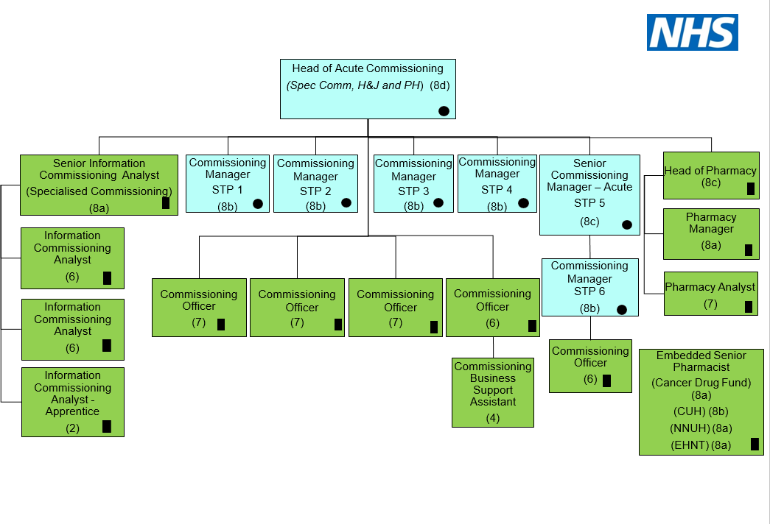

Person specification

Criteria |  | Essential | Desirable | Evidence*
Qualifications | A-Level or equivalent level of qualification.  A minimum of five GCSEs at Grade C or above, including English and Mathematics, or equivalent level of qualification, or significant equivalent previous proven experience. | √  √ |  | A/I
Knowledge and  experience | Previous experience of working in an administrative environment using computerised data systems.  Experience of working in a health care environment.  Awareness of a range of Health Services provisions.  Good knowledge and skills with Microsoft Office including Word and Excel.  Knowledge of NHS issues. | √  √ | √  √  √ | A/I
Skills Abilities and Attributes | Able to work within defined policies and procedures, using initiative and seeking advice when needed.  A good understanding of customer service.  Good numeric and analytical skills.  Able to explain processes and procedures to those unfamiliar with them.  Clear communicator with good writing, data entry and telephone skills ensuring accuracy.  Ability to work effectively as part of a team.  Problem solving skills – ability to work in a fast-paced environment.  Maintain a professional exterior in challenging situations.  Able to work on own initiative, organising and prioritising own workload to set deadlines.  Works well with others, is positive and helpful, listens, involves, respects and learns from the contribution of others.  Consistently looks to improve what they do, looks for successful tried and tested ways of working, and also seeks out innovation. | √  √  √  √  √  √  √  √  √  √  √ |  | A/I
Values and Behaviours | Fosters good working relationships and values diversity and difference.  Upholds the Equality Act 2010 and the Public Sector Equality Duty.  Upholds our commitments as a Stonewall Diversity Champion, Disability Confident Employer and Mindful Employer.  Promotes high standards for improving diversity and equality, as per the Workforce Race Equality Standard and Workforce Disability Equality Standard.  Promotes gender equality and closing our Gender Pay Gap.  Commitment to and focused on quality, promotes high standards in all they do.  Able to make a connection between their work and the benefit to patients and the public.  Consistently thinks about how their work can help and support clinicians and frontline staff deliver better outcomes for patients.  Values diversity and difference operates with integrity and openness.  Actively develops themselves and supports others to do the same.  Understanding of and commitment to equality of opportunity and good working relationships. | √  √  √  √  √  √  √  √  √  √  √ |  | A/I
Other | An ability to maintain confidentiality and trust and an awareness of information governance requirements and data protection. | √ |  | A/I
* Evidence will take place with reference to the following information:
A | Application form
I | Interview
T | Test or Assessment
C | Certificate

KEY TO JOB DESCRIPTION AND PERSON SPECIFICATION COLOUR CODING

 | Light Blue | JOB SPECIFIC INFORMATION: Text can be amended or additional information inserted
 | Dark Blue | ORGANISATION SPECIFIC INFORMATION: Text should not be amended
 | Black | NATIONAL GENERIC INFORMATION: Text should not be amended (denotes banding)

