**HeaderJob Description**

**Job Details**

|  |  |
| --- | --- |
| Job Title: | Support Accountant – Management Accounts and Controls Team |
| Job Reference Number: | Finance Undergraduate – Support Accountant |
| Band: | 2 |
| Ward / Department: | Finance |
| Directorate / Locality: | Corporate - Finance & Performance |
| Essential Qualifications: | Completed year 2 of an Undergraduate Degree Course |

**Job Purpose**

To assist in the management accounting and financial reporting of assigned Business Units.

To assist in producing budgets, forecasts and regular performance reports in line with the department’s reporting framework and timetable.

To assistant in the administration of financial controls and systems updates.

To undertake all financial administration of the Trust’s lease car arrangements and overpayments.

To undertake the additional duties and procedures required to complete the annual accounts.

**Organisational Arrangements**

|  |  |
| --- | --- |
| Accountable To: | Finance Business Partner |
| Reports To: | Finance Business Partner |
| Responsible For: | NA |

**Structure Chart – example of the standard Team Structure for Management Accounts**

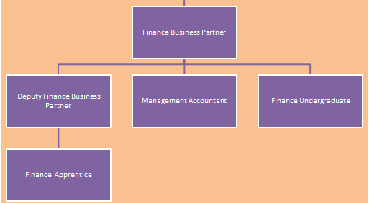

**Structure Chart – Controls Team**

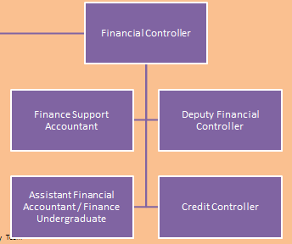

**Main Duties & Responsibilities**

**Management Accounting (8 months)**

1. To calculate and enter transactions in the general ledger as required under the supervision of the Finance Business Partner/Deputy Finance Business Partner.
2. To raise any invoices attributable to the assigned Business Unit(s) and to follow up with any late payment of these invoices.
3. To assist the Business Unit(s) in achieving its Better Payment Policy (BPP) targets, by reviewing reports and liaising with authorisers/suppliers to resolve any issues on a weekly basis.
4. To assist in preparation of returns to external bodies as required for review by the Finance Business Partner/Deputy Business Partner.
5. To assist in preparation of the annual budget and forecasts for the assigned Business Unit(s) in accordance with the departmental framework and timetable.
6. To assist in ensuring the Business Unit(s) meets its budget review compliance target by liaising with budget managers on a monthly basis.
7. To prepare internal recharges for the usage of temporary staff and other costs to be shared across Business Units.
8. To assist in the production of accurate financial reports under the guidance of the Finance Business Partner/Deputy Business Partner for the Business Unit(s) assigned to him/her in accordance with the monthly timetable.
9. To assist staff within the Business Unit(s) when required to ensure that the Business Unit’s financial affairs are conducted in accordance with the Trust’s prevailing financial procedures and controls which are in operation.

**Assistant Financial Accountant (4 months)**

1. To calculate and enter transactions , under the supervision of the Finance Controller and Deputy Finance Controller] in the general ledger in relation to :
2. Suspense accounts
3. PDC
4. Depreciation
5. Capital
6. Support the Finance Controller in the preparation work for the end of year accounts
7. Assist the Finance Controller in the submission of regulatory returns to NHSI.
8. Provide the finance support for leavers in the organisation and their removal from Finance systems and processes.
9. To assist in the management of the chart of accounts master data. Updating data in Integra and the master file and create, amend and deactivate cost centres and expense heads.
10. To assist the Finance Controller in the management of overpayments to staff, the chasing of recovery and P-Docs to rectify the overpayments
11. Assist in the support of the financial activity for lease cars

**General**

1. Under the guidance of the Finance Business Partner and Finance Controller undertake additional duties and procedures required to complete the annual accounts in accordance with the Department of Health Manual for Accounts and to national timetables and to provide additional information and explanations required by external auditors for the annual accounts.
2. To comply with the audit requirements and ensure that procedure notes are kept up to date. This includes completing detailed year-end audit files as appropriate.
3. To proactively propose changes to department working practices.
4. To undertake any ad-hoc or other duties that may be reasonably required for the Trust.
5. To be responsible for maintaining own personal development.

**Trust Values**

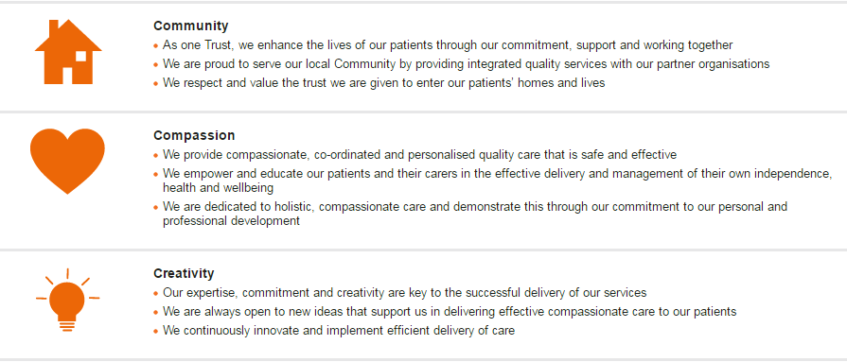

**Trust Behaviour Framework**

* All post holders are required to adhere to the Trust’s Behaviour Framework in the undertaking of their duties.

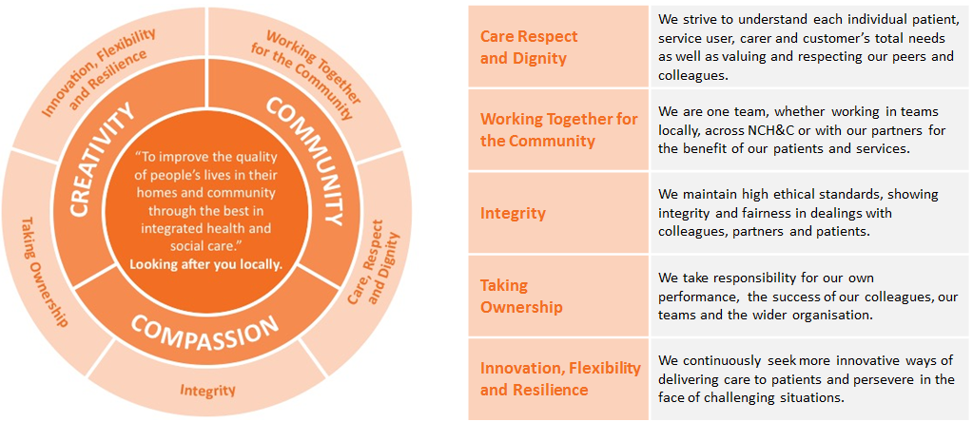

**Research & Development (**Should the post require more than this level then the requirement should be clearly described and referred to the AfC Panel for Evaluation)

* May be required to undertake surveys or audits, as necessary to own work; may occasionally participate in R&D, clinical trials or equipment testing.

**Safeguarding Clause**

* Norfolk Community Health and Care NHS Trust is committed to safeguarding and promoting the welfare of children, young people and vulnerable adults, and expects all staff and volunteers to share this commitment. Rigorous recruitment checks are carried out and where applicable to the role successful applicants will be required to undertake a criminal records check via the Disclosure and Barring Service (DBS).

**Infection Control**

* Norfolk Community Health and Care NHS Trust staff are responsible for protecting themselves and others against infection risks. All staff regardless of whether clinical or not are expected to comply with current infection control policies and procedures and to report any problems with regard to this to their managers. All staff undertaking patient care activities must attend infection control training and updates as required by Norfolk Community Health and Care NHS Trust.

**Health and Safety**

* Employees must be aware of the responsibilities placed upon them under the Health and Safety at Work Act (1974), to ensure the agreed safety procedures are carried out to maintain a safe environment for employees and visitors.
* To ensure that the Trust’s Health and Safety Policies are understood and observed and that procedures are followed.
* To ensure the appropriate use of equipment and facilities and the environment is maintained in good order.
* To take the necessary precautions to safeguard the welfare and safety of themselves, patients, staff and visitors, in accordance with the Health and Safety at Work Act.
* To undertake appropriate Health and Safety training to support safe working practice including, where appropriate, its management.

**General**

* All staff are required to respect confidentiality of all matters that they learn as a result of the employment with the Trust, including matters relating to other members of the staff and members of the public/patients.
* Maintain appropriate patient and clinical records in line with the Trusts policies and procedures, and in line with the agreed service specification.
* The post holder will be expected to participate in an annual appraisal of their work where the job description will be reviewed and objectives set. In line with the annual personal development plan the post holder will be expected to undertake any training or development required to fulfil their role.
* Ensure that all patients, clients and colleagues are treated at all times in an equitable manner, respecting diversity and showing an understanding of diversity in the workplace.
* The post holder must carry out their responsibilities with due regard to the Trust’s Equality and Diversity Policies, Procedures and Schemes and must ensure that equality is promoted at all times.

This job description is not exhaustive and may be amended from time to time in consultation with the post holder. The post holder will be required to undertake any other duties as may be required for the effective performance of the post.

**Person Specification**

**Essential** defines the minimum criteria needed to carry out the job and the job cannot be done without these.

**Desirable** refers to criteria which are not essential and which successful applicants would be expected to acquire during their time in post. The desirable requirements are not taken in to consideration in a job evaluation panel.

|  |  |  |
| --- | --- | --- |
|  | **Essential Critiera** | **Desirable Criteria** |
| **Education/ Qualification** | * Completed year 2 of an undergraduate degree course | * Degree to be Accountancy or Finance related. |
| **Experience** | * Not essential but desirable | * Experience of working in a finance environment with knowledge of reconciliations, double entry book-keeping, payables, receivables and financial systems. |
| **Skills/ Ability** | * Good communication skills. Ability to communicate with internal and external managers. * Good technical skills and use of IT systems, particularly MS Excel. * Team player with an ability to work closely with others. | * Ability to communicate with all levels of staff. |
| **Knowledge/ Understanding** | * Not essential but desirable | * Knowledge of financial and accounting procedures. * Using Information Technology.   Ensures that financial information provided to others is accurate, timely and useful |
| **Values/ Attitudes** | * Motivated and able to prioritise own workload. * Able to work under pressure and meet deadlines. |  |

**Supplementary Information**

**Manager responsible for completion of this document**

|  |  |
| --- | --- |
| Name: |  |
| Member of Staff to whom this document relates: |  |
| Date Completed: |  |
| Review Date: |  |

Post Holder’s Signature ………………………………………..

Manager’s Signature ………………………………………..

Date Job Description Agreed ………………………………………..

**DISTRIBUTION:** One copy to member of staff, one copy to personal file.

**Please ensure Job Description is agreed and signed by both manager and employee**