NHS Cambridgeshire & Peterborough Integrated Care Board
Job Description
Job Title: | Accounts Assistant – Student Placement
Band: | Agenda for Change Band 2
Directorate: | Finance
Base Location: | Home based
 | Ability to travel to other sites and Gemini House as required
Worker Status: | Home Worker
On call rota: | N/A
Contracted Hours: | Full time (37.5hrs per week)
Reporting to: | Senior Finance Manager
Accountable to: | Assistant Chief Finance Officer

Key Working Relationships: Complex Case Team, Finance, Legal Firms, Patients, Care Homes, Local Authority, General Practitioners, Practice Managers, Primary Care Professionals and Home Care Providers.

General Information

ICB Vision
All together for healthier futures. We are an anchor system that intentionally enhances social value for its communities and workforce.

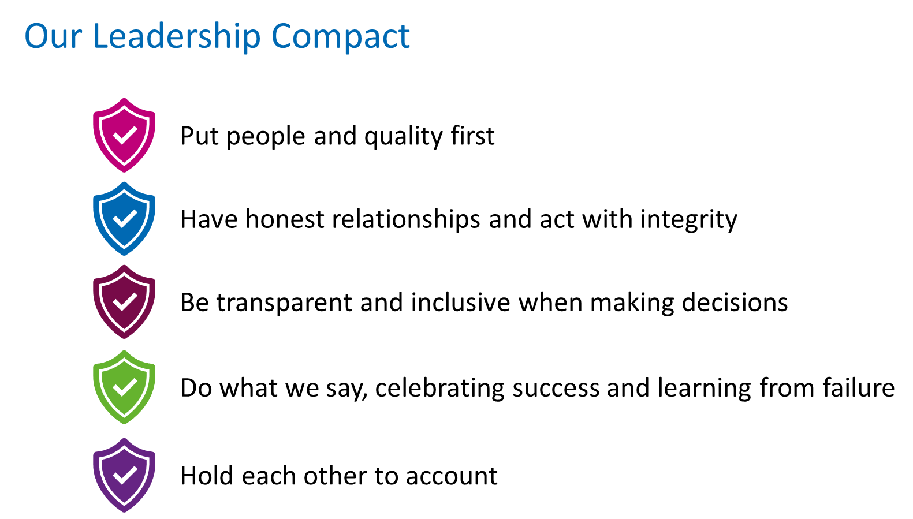
To achieve these ambitions, we will need to build a strong culture that values diversity. Therefore, the post holder will need to bring a natural lived experience to the work.

Job Purpose

Provide a professional support role to both the Complex Case Finance Team specifically, to support Personal Health Budgets as well as the Primary Care finance team. This will involve ensuring the appropriate financial governance is in place to monitor expenditure in this area

Provide a highly comprehensive and confidential support to the Senior Finance Manager, and to the Complex Case Team as well as Primary Care team, ensuring effective communication on confidential matters on a day-to-day basis with several different parties, both internal and external to the ICB.

Key Duties and Responsibilities

Main Duties and Responsibilities:
• Liaise with all relevant parties, including patients, in order to obtain documentation required for audit of Personal Health Budget accounts.
• Calculate payments due in respect of individual budgets agreed by the Complex Case Team.
• Keep an accurate record of payments made, balances owed and monies reclaimed for each patient with an agreed Personal Health Budget.
• Ensure payments are entered into the purchase ledger correctly, and payment is made in a timely manner in accordance with the NHS Better Payments Practice Code.
• Report into the Senior Finance Manager with regular updates regarding monies to be reclaimed where funds remain unspent.
• Management and maintenance of the Primary care generic mailbox as well as the payment master file.
• Support the financial aspects of primary care contracting including making monthly contract payments and calculating payment adjustments.
• Reconciliation of ledger to assist with month end reporting process.
• Seek advice from the Senior Finance Manager where there are issues with resolving queries.
• Working autonomously on a day-to-day basis, providing cover for all matters of everyday administration, including taking the initiative to ensure necessary follow-up actions are undertaken.

Communication:
- The post holder will be required to work actively with a wide range of professionals within the organisation and external bodies:
- ICB Managers and staff (clinical and non-clinical)
- Service Users
- Providers
- Practice Managers and General Practitioners
- Internal and External Auditors
- External Service Providers (e.g. SBS and ADAM)
- NHS England and Local Representatives
- Other professional and non professional individuals
- The wider finance team

The post holder will be required to exercise sensitivity and empathy when communicating with patients and/or their families regarding highly sensitive issues.

This job description is intended only as a guide to the range of duties involved including working within the Primary Care Finance Team. The post holder will need to be flexible and adaptable in order to respond to other duties that may be required from time to time and the changes and developments within C&P ICB.

Relevant to All ICB Staff

- All employees must comply with the Single Equality Scheme and must not discriminate on the grounds of sex, colour, race, ethnic or national origins, marital status, age, disability, sexual orientation, or religious belief.

- NHS Cambridgeshire & Peterborough is committed to safeguarding and promoting the welfare of children, young people and adults who are at risk of neglect or abuse and expects all staff and volunteers to share this commitment.

- Employees have a responsibility to themselves and others in relation to managing risk, health and safety and will be required to work within the policies and procedures laid down by NHS Cambridgeshire and Peterborough. All staff have a responsibility to access occupational health, other staff support services and/or any relevant others in times of need and advice.

- All employees are subject to the Data Protection and Freedom of Information Acts and must maintain strict confidentiality of information in accordance with NHS Cambridgeshire and Peterborough policy and, where applicable, with the relevant policy of their professional body. The post holder may access information only on a need-to-know basis in the direct discharge of duties and divulge information only in the context of calculated Data Protection Guidelines.

- Any data that is taken/shared as part of a phone call or transported, faxed, or transferred electronically must be undertaken with regard to NHS Cambridgeshire and Peterborough Information Governance and Information Security policies.

- Maintain own professional development and take part in annual performance appraisal process.

- Undertake mandatory training and any other training relevant to the role as required by NHS Cambridgeshire and Peterborough.

- The post holder is required to participate in relevant emergency preparedness processes for their team.

- NHS Cambridgeshire and Peterborough seek to establish a safe and healthy working environment for its employees and operate a non-smoking policy.

- All of the above activities are governed by the operational policies, standing financial instructions, policies and procedures and standards of NHS Cambridgeshire and Peterborough, as well as legislation and professional standards and guidelines.

- The post holder must participate in clinical and other audits as required.

- The job description and person specification are an outline of the tasks, responsibilities and outcomes required of the role. The job holder will carry out any other duties as may reasonably be required by their Line Manager.

- This is a description of the job as it is at present constituted. It is the practice of NHS Cambridgeshire and Peterborough to regularly examine employees’ job descriptions and to update them to ensure they relate to the job as then being performed, or to incorporate whatever changes are being proposed. This procedure is jointly conducted by each manager and those working directly to him or her. You will, therefore, be expected to participate fully in such discussions and, in connection with them, to re-write your job description to bring it up to date if this is considered necessary or desirable. The aim is to reach agreement on reasonable changes, but if agreement is not possible NHS Cambridgeshire and Peterborough reserves the right to insist on changes to your job description after consultation with you.

- All organisations have a legal duty to check employees’ documentation to ensure they are entitled to work in the UK and failure to conduct appropriate checks can result in criminal prosecution and/or a fine of up to £10,000 for each illegal worker. Therefore, NHS Cambridgeshire and Peterborough will undertake checks on all new starters and may involve its Local Counter Fraud Office to ensure that the identity documentation that has been provided by prospective employees is genuine.

- All new employees to NHS Cambridgeshire & Peterborough are subject to the completion of a three-month probation period. In line with the Agenda for Change NHS Terms and Conditions of Service, all terms and conditions of employment will have continuous service from the first day of employment at the start of the probationary period, not from the end of the probationary period.

- An essential component of the ICB is to ensure that all staff comply with the governance requirements of ICB’s policies and procedures in place to ensure full compliance across the organisation Staff should make themselves aware of and comply with all relevant policies, including:

- ICB Constitution
- Standards of Business Conduct and Managing Conflicts of Interest
- Standing Financial Instructions (embodied within the ICB Constitution)
- Standards of Business Conduct and Commercial Sponsorship Policy
- Raising Issues of Serious Concern at Work (Whistleblowing) Policy and Procedure
- Counter Fraud Policy
- Anti-Bribery Policy

- The above list is not exhaustive and may be varied by the NHS Cambridgeshire and Peterborough as required.
NHS Cambridgeshire & Peterborough Integrated Care Board Person Specification

Job Title: Accounts Assistant

Band: 2

Directorate: Finance

 | Essential Criteria | Desirable Criteria | Measure
Qualifications and Training | - Good general education  - GCSE English or equivalent  - GCSE Maths or equivalent | • Studying for AAT qualification | Application/ certificate check
Experience | - 2 years experience of working in a financial setting or equivalent.  - Working knowledge of finance systems.  - Good knowledge of bookkeeping.  - Sound ledger experience.  - Good working knowledge of spreadsheets  . |  | Application/ Interview/ Presentation
Skills, ability and knowledge | - Ability to analyse and interpret financial and other information.  - Excellent verbal and written communication skills to enable effective communication with a wide range of stakeholders.  - Ability to plan, organise and prioritise own workload to achieve deadlines.  - Excellent IT skills including Excel, Word, PowerPoint and Access.  - Knowledge of financial and accounting procedures. |  | Application/  Interview/ Presentation
Personal attributes | - Proactive and constructive outlook.  - Team player with ability to establish sound relationships.  - Self-motivated.  - Tactful and diplomatic.  - Friendly and approachable.  - Flexible and adaptable approach as the role develops and changes.  - Ability to remain calm and work effectively in a busy .environment.  - Good time management.  - Enthusiasm to learn and develop. |  | Application/ Interview/ Presentation
Safeguarding and promoting the welfare of children and young people/adults who are at risk of neglect or abuse | - Demonstrates understanding of safeguarding issues. |  | Application/ Interview/ Presentation
Working within Professional Boundaries | - Highly motivated and resourceful  - Able to maintain high standards of diplomacy and understands the principle of confidentiality.  - Accepts responsibility and accountability for own work and can define the responsibilities of others.  - Able to establish positive relationships and mutual respect with people at all levels .  - Ability to contribute effectively. |  | Application/ Interview/ Presentation
Emotional Awareness | - Demonstrates empathy and concerns for others  - Shows respect for others’ feelings, views and circumstances  - Able to work within an environment where there may be significant barriers and resistance to change.  - Occasional indirect exposure to highly emotional circumstances. |  | Application/ Interview/ Presentation
Self-awareness | - Can demonstrate a flexible approach  - Has realistic knowledge of personal strengths and areas for development |  | Application/ Interview/ Presentation
Behaviour we expect | - Treat everyone in a friendly, courteous manner  - Treat colleagues and contacts with dignity and respect  - Understand people come from varied backgrounds: challenge bias, prejudice and intolerance  - Learn from mistakes and ask for support where necessary  - Look for better ways of working to achieve improvements  - Question poor behaviour  - Uphold the values of NHS Cambridgeshire & Peterborough and be proud to be part of the ICB

Mobility - Some roles within the ICB are not suitable for the sole use of public transport and/or where a long journey from home to where work routinely takes place. |  | AF/interview

NB: The order of the list of criteria, do not indicate importance

